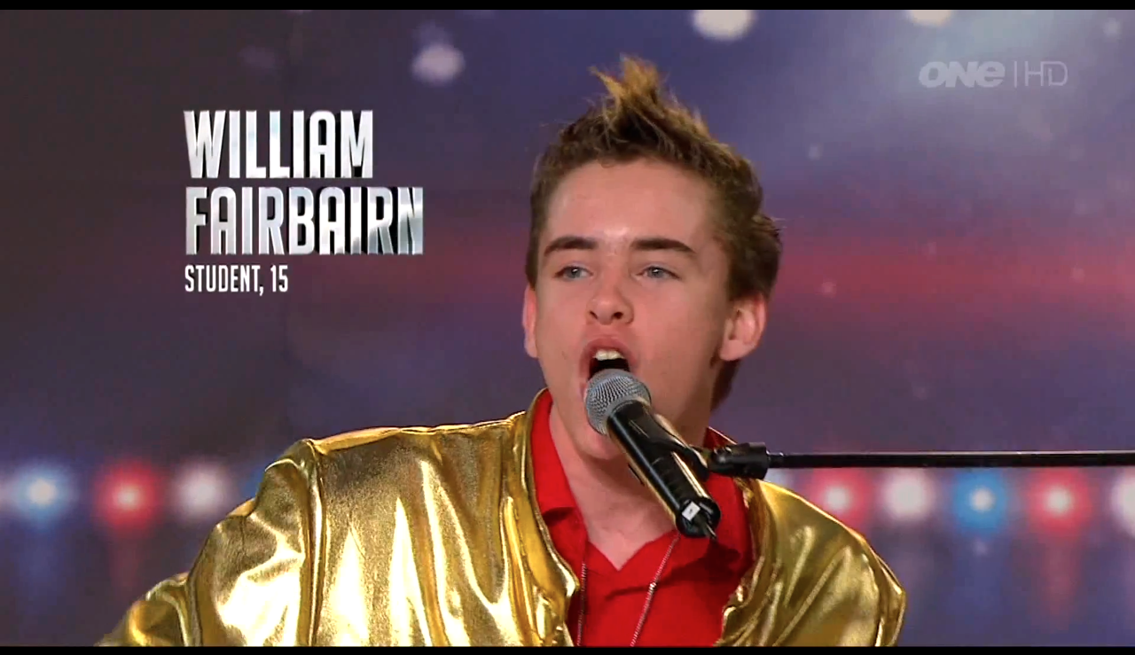
Nelson’s own, Music Prodigy!
William Fairbairn Is in the Semi Finals!
TV One Sunday 4th November 7:30 pm
Please Text “William” to 8981 after the show to vote
Voting closes on Tuesday, at 12pm.
(Texts cost 0.99 cents each)
www.williamfairbairn.com
THANK YOU SO MUCH!

